ECPHRASTIC POETRY ACTIVITY
CHEMISTRY

Using the given stimulus material, create the following types of poetry:
- Free verse
- Acrostic
- Cinquain
- Haiku
- Limerick
Remember to complete the following steps:
- View a stimulus image and identify a chemistry-related concept it evokes.

- If required, write down the concept, definition, law, formula etc.

- Identify a suitable poetry type and write the poem.

STIMULUS IMAGE 1
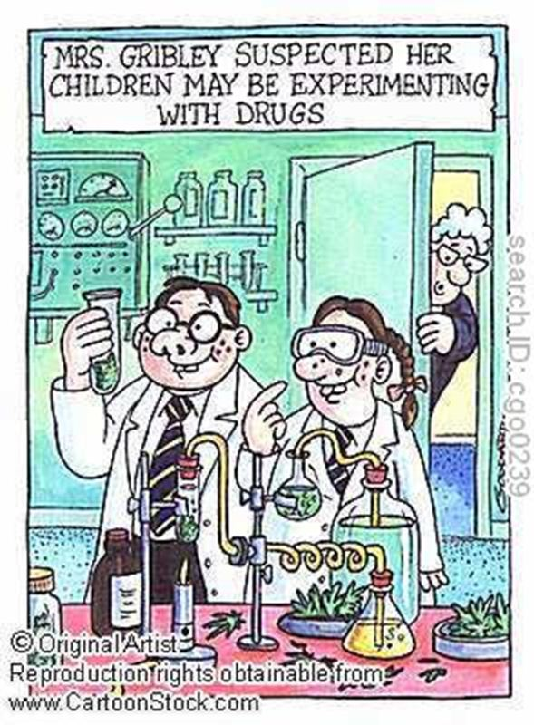
www.cartoonstock.com/lowres/cgo0239l.jpg
STIMULUS IMAGE 2
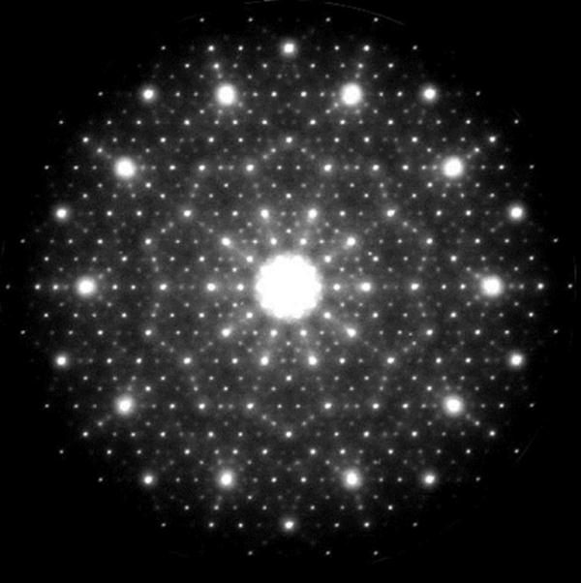
http://www.chemistryland.com/CHM151S/07-Atomic%20Structure/Spectra/ElectronDiffractionAlNiCo.jpg

STIMULUS IMAGE 3
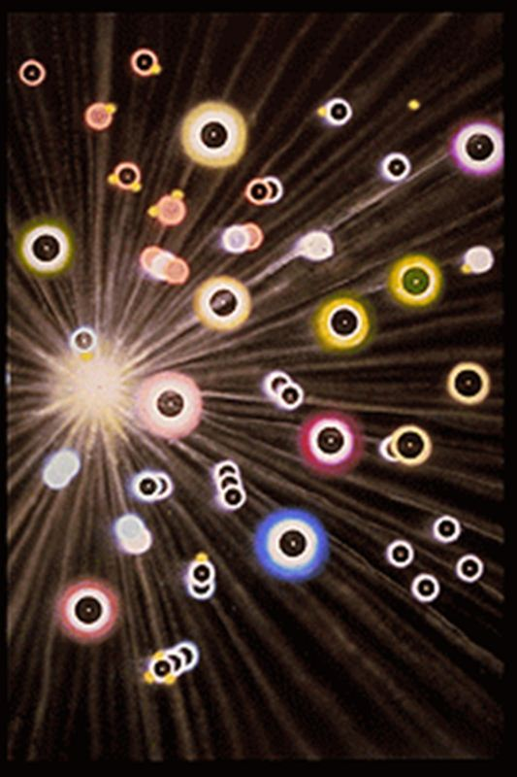
http://www.jonlomberg.com/images/digital_prints/dp_molecules_in_comets_tail_t.gif
STIMULUS IMAGE 4
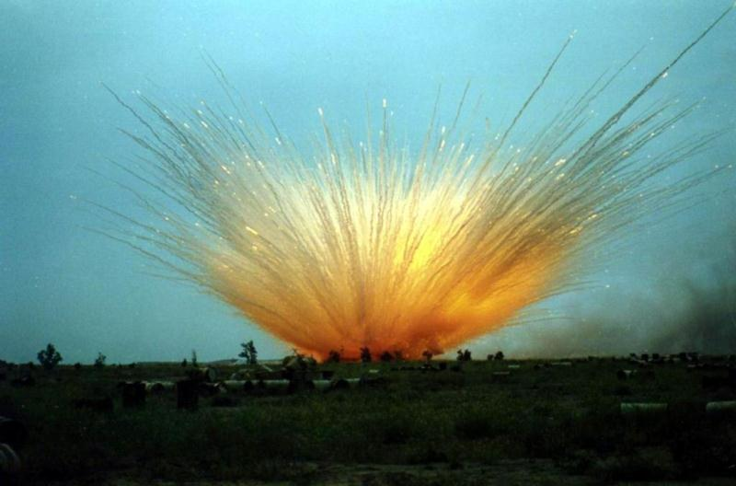
http://static.panoramio.com/photos/original/3042398.jpg

STIMULUS IMAGE 5
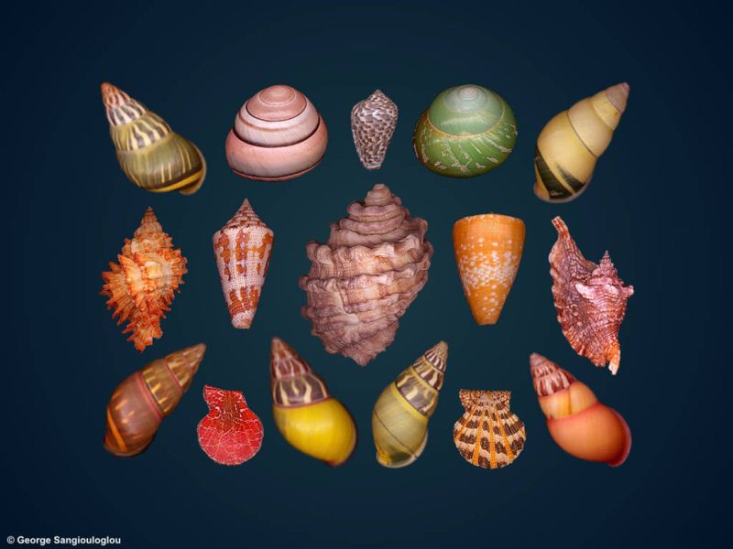
http://www.george-shells.com/wallpaper/shells_apr03dgr.jpg

